Data Structures (ETCCDS202)
Unit–3 Assignment: Sorting Algorithms



Nam:- Rakshit Pal
CLASS:– B. TECH CSE(ROBOTICS & Ai)
SUBMITED TO:– AARTI MA’AM
SUBMITED BY:-Rakshit Pal
ROLL NO :-2501630004

Task 1: Implement the Core Sorting Algorithms (From Scratch)
Goal: Implement sorting logic and understand trade-offs.
1. Implement Insertion Sort:
• Function: insertion sort(arr)
• Should sort the list in non-decreasing order.
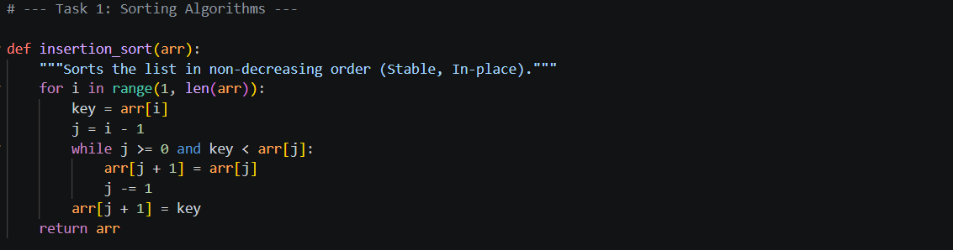
2. Implement Merge Sort:
• Function: merge sort(arr)
• Must include a helper merge(left, right).
• Note: This is typically stable and uses extra space.
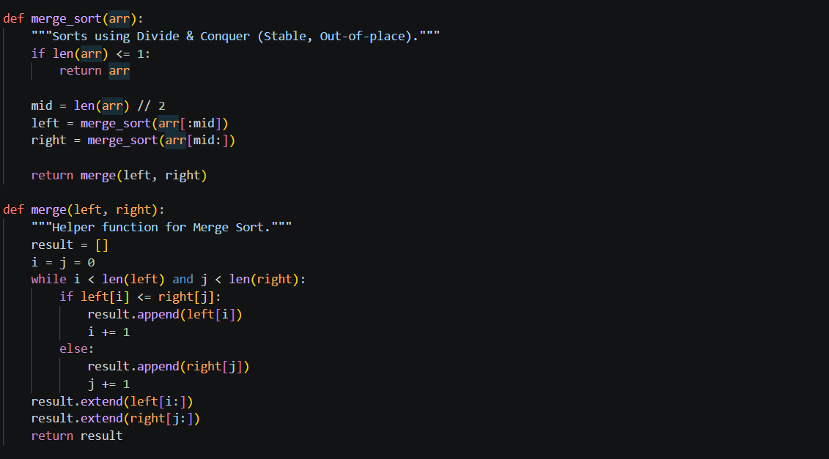

3. Implement Quick Sort:
• Function: quick sort(arr, low, high)
• Choose a pivot strategy (recommended: last element as pivot).
• Implement partitioning (Lomuto or any clear scheme).
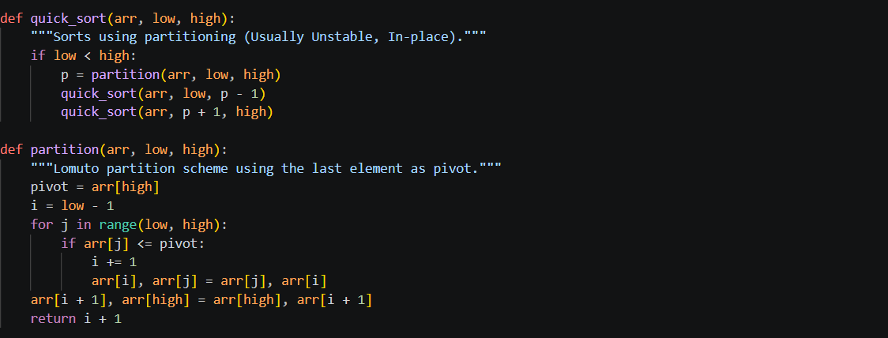
Task 2: Performance Measurement and Dataset Generation
Goal: Measure time fairly and compare behavior on different inputs.
(A) Timing Utility
Write a function measure time(sort func, arr) that:
• takes a sorting function and a list
• makes a copy of the list (so each algorithm sorts the same data)
• returns execution time in milliseconds (or seconds)
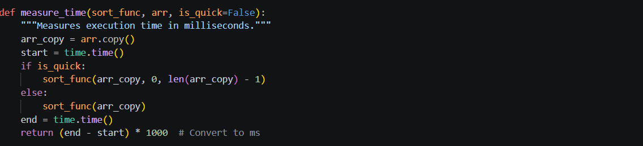
(B) Dataset Generator
Generate the following datasets:
• Random lists of sizes: 1000, 5000, 10000
• Already sorted lists of sizes: 1000, 5000, 10000
• Reverse-sorted lists of sizes: 1000, 5000, 10000
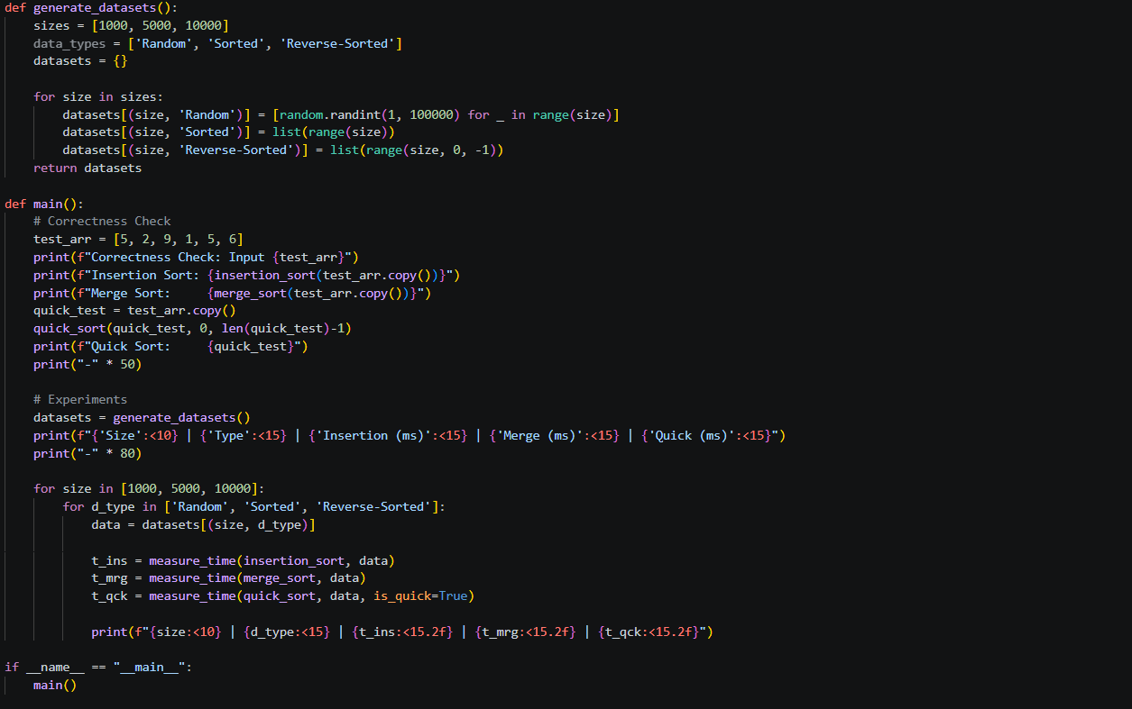
(C) Run Experiments
For each size and input type:
• Run Insertion Sort
• Run Merge Sort
• Run Quick Sort
• Record times in a neat table format
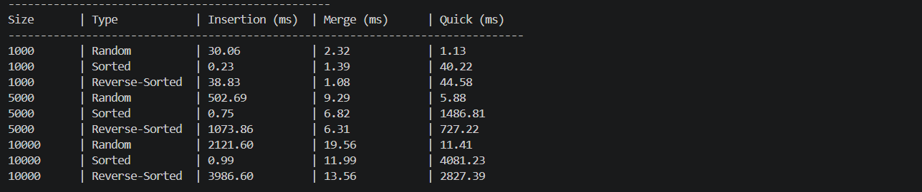

Task 3: Analysis and Comparison (Report)
Goal: Connect practical results with theoretical complexity.
- Report added in folder of DSA Assignment 3.
- GITHUB LINK - https://github.com/palrakshit7914-hub

